**Wemos D1 Mini ESP32 Specifications**

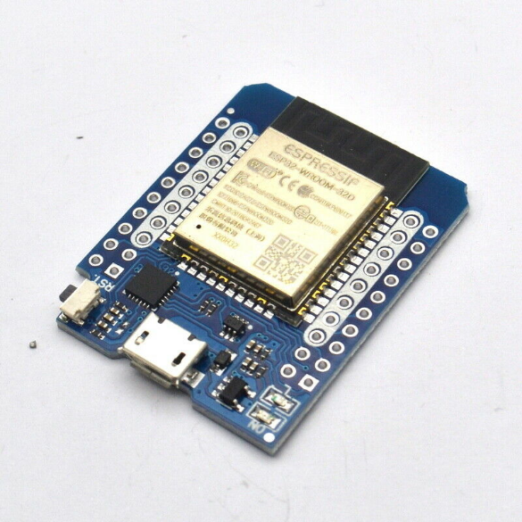

|  |  |  |
| --- | --- | --- |
| **Board** | **Name** | Wemos D1 Mini ESP32 |
| **Microcontroller** | ESP-WROOM-32 | |
| **USB connector** | Micro-USB B | |
| **Pins** | **GPIO** | 32 |
| **ADC** | 4 |
| **DAC** | 1 |
| **Communication** | **UART** | Yes, 2 |
| **I2C** | Yes |
| **SPI** | Yes |
| **SDIO** | Yes |
| **SD Card** | Yes |
| **Wireless Communication** | **WiFi** | 802.11 b/g/n (802.11n up to 150Mbps)  2.4GHz |
| **Bluetooth** | V4.2 BR/EDR and BLE specifications |
| **Power** | **I/O Voltage** | 3.3V |
| **Input voltage (nominal)** | 3.3V-5V |
| **DC Current per I/O Pin** | 20 mA |
| **Supported battery** | 5V battery |
| **Power Supply Connector** | VCC Pin & Micro-USB |
| **Clock speed** | **Main Processor** | Xtensa 32-bit LX6 40MHz |
| **Internal Memory** | **ROM** | 448KB |
| **SRAM** | 520KB on chip, 8KB on RTC |
| **eFuse** | 1Kbit, 256 bits MAC address, 768 bits flash encryption and chip-ID |
| **External Memory** | **QSPI** | 11MB + 248KB CPU Instruction Memory space 4MB Read-Only data memory |
| **SRAM** | 4MB CPU data memory |
| **Dimensions** | **Weight** | 12 g |
| **Width** | 31.5 mm |
| **Length** | 39 mm |

**Reference:** [D1 Mini ESP32 WiFi + Bluetooth (arduino-projekte.info)](https://arduino-projekte.info/produkt/d1-mini-esp32-wifi-bluetooth/)

**DS18B20 Digital Temperature Sensor Specifications**

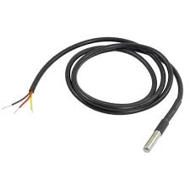

|  |  |  |
| --- | --- | --- |
| **Sensor** | **Name** | DS18B20 Digital Temperature Sensor |
| **Material** | Stainless Steel #316 | |
| 6mm Diameter and 40mm Long Tube | |
| **Wiring** | **Black** | Ground |
| **Red** | VCC |
| **Yellow** | Digital Output |
| **Bluetooth** | V4.2 BR/EDR and BLE specifications |
| **Power** | **VCC Input** | 3V-5V |
| **Temperature Range** | -55°C to 125°C (±0.5 °C Accuracy from -10 °C to +85 °C) | |
| **Resolution** | 9bits to 12bits | |
| **Query Time** | <750ms | |
| **Dimensions** | **Weight** | 12 g |
| **Length** | 900 mm |

**Reference:** [High Temp Waterproof DS18B20 Digital temperature sensor (evilmadscientist.com)](https://shop.evilmadscientist.com/productsmenu/717)

**PH-4502C pH Sensor Specifications**

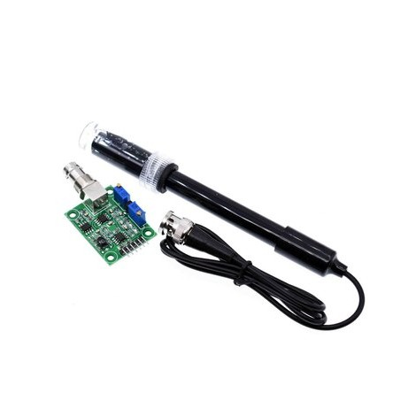

|  |  |  |
| --- | --- | --- |
| **Board** | **Name** | PH-4502C pH Sensor |
| **Signal converter board** | PH-4502C | |
| **Electrode** | E201-BNC (Laboratory Type) | |
| **Pins** | **VCC** | 3.3V-5V @10mA |
| **GND** | Ground for Board |
| **GND** | Ground for pH Electrode |
| **PO** | pH Analog Output |
| **DO** | 3.3V pH Limit Trigger |
| **TO** | Temperature Output |
| **Reading TIme** | **Response Time** | <5s |
| **Stability Time** | <60s |
| **Detection Range** | 0pH – 14pH (Acid / Base) | |
| **Dimensions** | **Height** | 20 mm |
| **Width** | 32 mm |
| **Length** | 42 mm |

**Reference:** [PH4502C PH Meter – ThinkRobotics.in](https://thinkrobotics.in/products/ph4502c-ph-meter)

**DFR0300-H Electrical Conductivity Sensor Specifications**

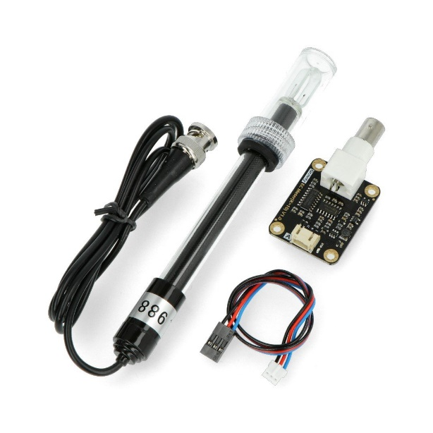

**SEN0237-A Dissolved Oxygen Sensor Specifications**

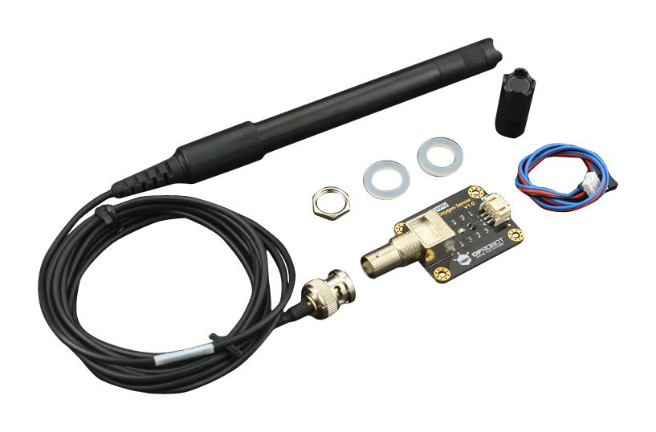

**6-24V to 5V 3A USB DC-DC Buck Converter Specifications**

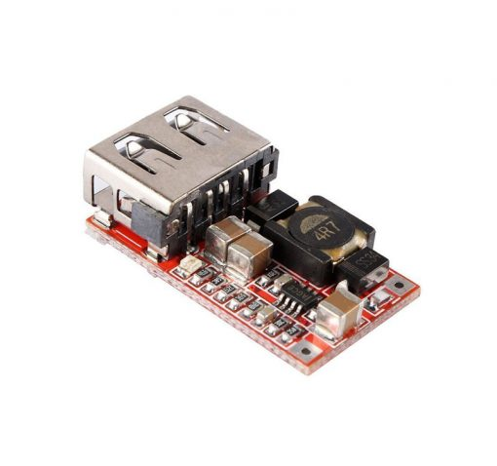

**LM2596S DC-DC Buck Converter Specifications**

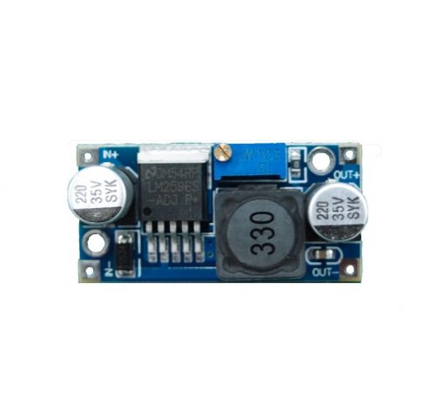

**SGM37-3530 37RPM 12V DC Gear Motor Specifications**

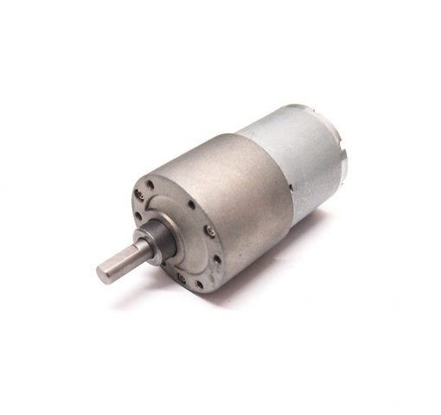

**L9110S Dual-H Bridge Motor Driver Specifications**

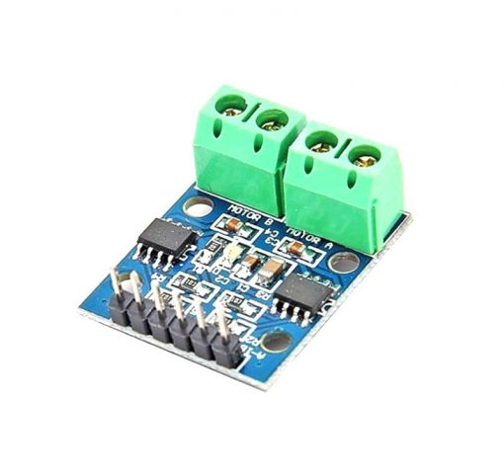

**4 Channel 5V Relay SPDT Module Specifications**

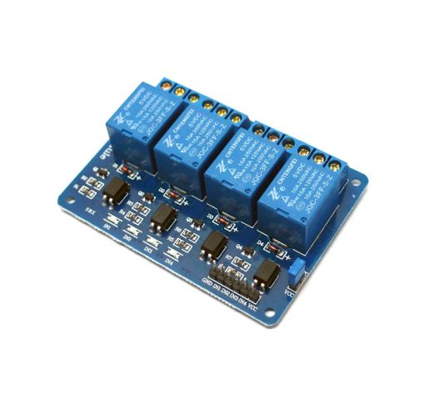

**74LS04N Hex Interver Specifications**

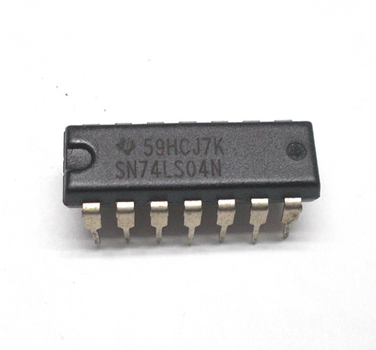

**RGB LED Specifications**

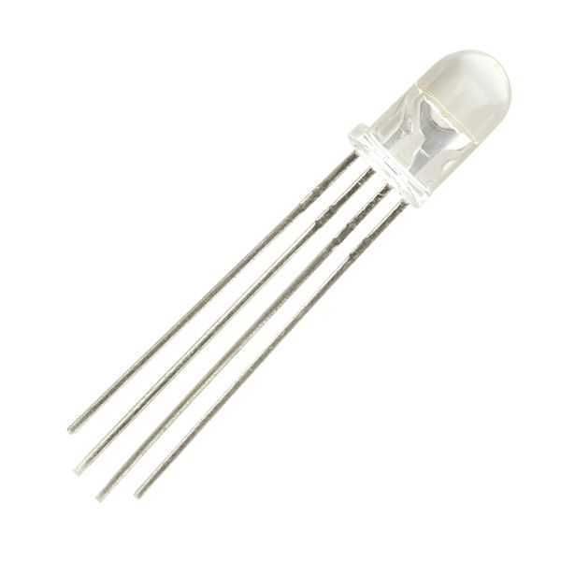

**Tactile Push Button Specifications**

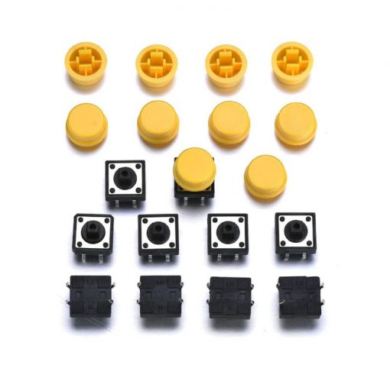

**16x2 I2C LCD White on Blue Specifications**

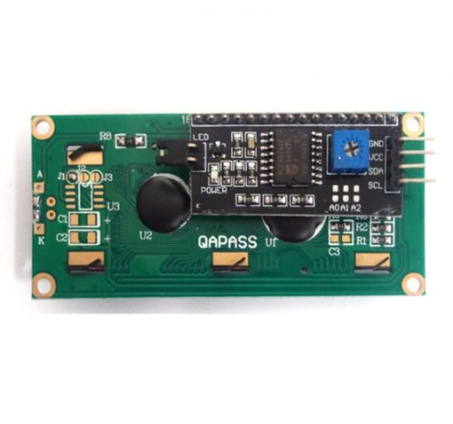

**Piezoelectric Buzzer Specifications**

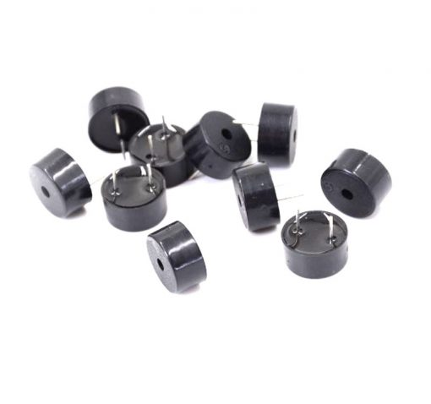

**12V DC Brushless Fan Specifications**

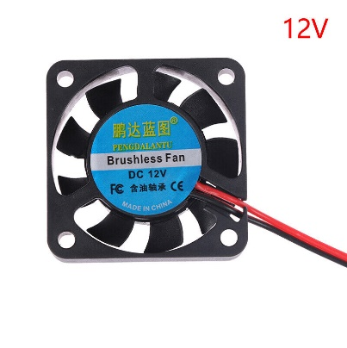

**12V 2A Power Adapter Specifications**

